**Backtesting program**

1. Backtesting 1.

In this first model the porpuse is to make the program 3.0 Multistock to analize each group of candles (4) of a past time, for example, from 1 january 2022 to today, in that way It will run 222 times (aproximally). The final result must be an excel file with the following specifications, the second picture shows where to find the first 4 data.

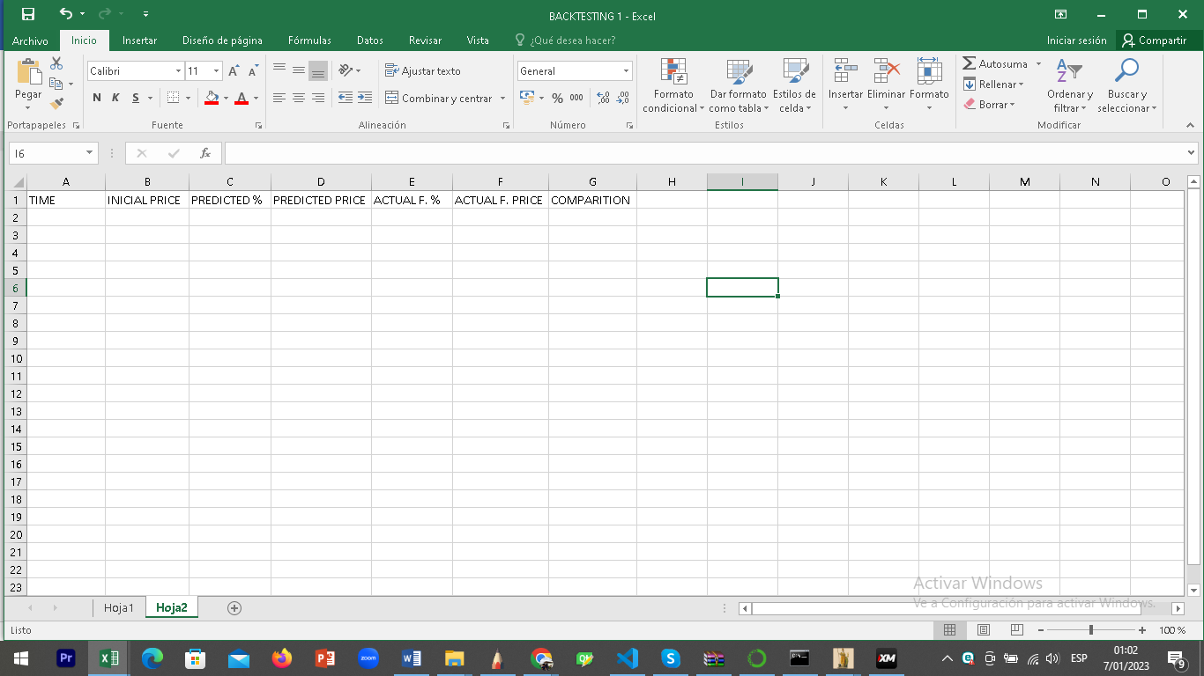.

TIME: “Actual data”

INICIAL PRICE: the number 1.1907030, it’s the initial price of the asset in the spicificate time.

PREDICTED %: “Predicted change”

PREDICTED PRICE: “4 hours ahead forecast”

ACTUAL F.%: it’s the actual “% change” of the price 4h ahead.

ACTUAL F. PRICE: It’s the actual price 4h ahead.

COMPARITION: (“ACTUAL F. %”/”PREDICTED %”)*100

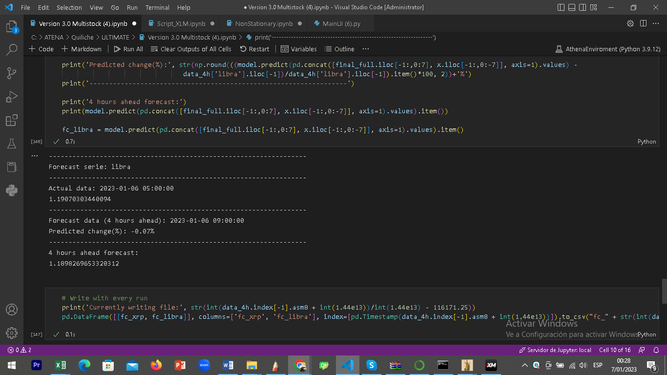

* In a new cell it must shown the following specifications.

Minimim Predicted %:

Maximum Predicted %:

Simple mean of Comparition:

* In another cell a small algoritm:

Simple mean of Comparition with results higher or equal than “X”